**DN 4.0 JAVA FSE SOLUTIONS – WEEK 3**

**SKILL: Spring Core and Maven**

**Exercise 1:** Configuring a Basic Spring Application

**Scenario:**

Your company is developing a web application for managing a library. You need to use the Spring Framework to handle the backend operations.

**Code:**

**Pom.xml -**

<?xml version="1.0" encoding="UTF-8"?>

<project xmlns="http://maven.apache.org/POM/4.0.0"

xmlns:xsi="http://www.w3.org/2001/XMLSchema-instance"

xsi:schemaLocation="http://maven.apache.org/POM/4.0.0 http://maven.apache.org/xsd/maven-4.0.0.xsd">

<modelVersion>4.0.0</modelVersion>

<groupId>com.library</groupId>

<artifactId>LibraryManagement</artifactId>

<version>1.0-SNAPSHOT</version>

<properties>

<maven.compiler.source>21</maven.compiler.source>

<maven.compiler.target>21</maven.compiler.target>

<project.build.sourceEncoding>UTF-8</project.build.sourceEncoding>

</properties>

<dependencies>

<!-- Spring Core -->

<dependency>

<groupId>org.springframework</groupId>

<artifactId>spring-context</artifactId>

<version>5.3.29</version>

</dependency>

</dependencies>

</project>

**BookRepository.java –**

package com.library.repository;

public class BookRepository {

public void saveBook(String title) {

System.out.println("Book saved in Book Repository: " + title);

}

}

**BookService.java -**

package com.library.service;

import com.library.repository.BookRepository;

public class BookService {

private BookRepository bookRepository;

public void setBookRepository(BookRepository bookRepository) {

this.bookRepository = bookRepository;

}

public void addBook(String title) {

System.out.println("Adding book to Book Repository: " + title);

bookRepository.saveBook(title); // Calls the method in repository

}

}

**applicationContext.xml -**

<?xml version="1.0" encoding="UTF-8"?>

<beans xmlns="http://www.springframework.org/schema/beans"

xmlns:xsi="http://www.w3.org/2001/XMLSchema-instance"

xsi:schemaLocation="http://www.springframework.org/schema/beans

http://www.springframework.org/schema/beans/spring-beans.xsd">

<bean id="bookRepository" class="com.library.repository.BookRepository" />

<bean id="bookService" class="com.library.service.BookService">

<property name="bookRepository" ref="bookRepository" />

</bean>

</beans>

**Main.java -**

package com.library;

import com.library.service.BookService;

import org.springframework.context.ApplicationContext;

import org.springframework.context.support.ClassPathXmlApplicationContext;

public class Main {

public static void main(String[] args) {

ApplicationContext context = new

ClassPathXmlApplicationContext("applicationContext.xml");

BookService bookService = context.getBean("bookService", BookService.class);

bookService.addBook("Ignited Minds");

}

}

**Output:**

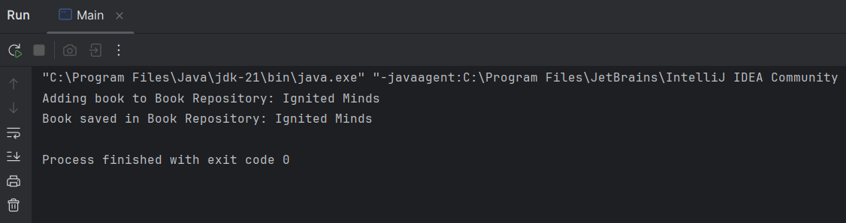

**Explanation:**

In this exercise, I set up a **basic Spring project using Maven**, defined BookService and BookRepository classes, and configured beans using applicationContext.xml. I used setter-based Dependency Injection to wire the beans, which is a fundamental part of Spring's IoC container. The application was successfully run using the Spring context.

**Exercise 2:** Implementing Dependency Injection

**Scenario:**

In the library management application, you need to manage the dependencies between the BookService and BookRepository classes using Spring's IoC and DI.

**Code:**

**Pom.xml -**

<?xml version="1.0" encoding="UTF-8"?>

<project xmlns="http://maven.apache.org/POM/4.0.0"

xmlns:xsi="http://www.w3.org/2001/XMLSchema-instance"

xsi:schemaLocation="http://maven.apache.org/POM/4.0.0 http://maven.apache.org/xsd/maven-4.0.0.xsd">

<modelVersion>4.0.0</modelVersion>

<groupId>com.library</groupId>

<artifactId>LibraryManagement</artifactId>

<version>1.0-SNAPSHOT</version>

<properties>

<maven.compiler.source>21</maven.compiler.source>

<maven.compiler.target>21</maven.compiler.target>

<project.build.sourceEncoding>UTF-8</project.build.sourceEncoding>

</properties>

<dependencies>

<!-- Spring Core -->

<dependency>

<groupId>org.springframework</groupId>

<artifactId>spring-context</artifactId>

<version>5.3.29</version>

</dependency>

</dependencies>

</project>

**BookRepository.java -**

package com.library.repository;

public class BookRepository {

public void saveBook(String title) {

System.out.println("Book saved in Book Repository: " + title);

}

}

**BookService.java -**

package com.library.service;

import com.library.repository.BookRepository;

public class BookService {

private BookRepository bookRepository;

public void setBookRepository(BookRepository bookRepository) {

this.bookRepository = bookRepository;

}

public void addBook(String title) {

System.out.println("Adding book to Book Repository: " + title);

bookRepository.saveBook(title); // Calls the method in repository

}

}

**applicationContext.xml -**

<?xml version="1.0" encoding="UTF-8"?>

<beans xmlns="http://www.springframework.org/schema/beans"

xmlns:xsi="http://www.w3.org/2001/XMLSchema-instance"

xsi:schemaLocation="http://www.springframework.org/schema/beans

http://www.springframework.org/schema/beans/spring-beans.xsd">

<bean id="bookRepository" class="com.library.repository.BookRepository" />

<bean id="bookService" class="com.library.service.BookService">

<property name="bookRepository" ref="bookRepository" />

</bean>

</beans>

**Main.java -**

package com.library;

import com.library.service.BookService;

import org.springframework.context.ApplicationContext;

import org.springframework.context.support.ClassPathXmlApplicationContext;

public class Main {

public static void main(String[] args) {

ApplicationContext context = new

ClassPathXmlApplicationContext("applicationContext.xml");

BookService bookService = context.getBean("bookService", BookService.class);

bookService.addBook("Ignited Minds");

}

}

**Output:**



**Explanation:**

In this exercise, I focused specifically on **implementing and verifying Dependency Injection** using Spring's XML configuration. I ensured the BookService class has a setter method for BookRepository, and updated the applicationContext.xml to inject the dependency via the property tag. Running the application confirmed that Spring correctly injected the dependency.

**Exercise 4:** Creating and Configuring a Maven Project

**Scenario:**

You need to set up a new Maven project for the library management application and add Spring dependencies.

**Code:**

**pom.xml -**

**<?**xml version="1.0” encoding="UTF-8"?>

<project xmlns="http://maven.apache.org/POM/4.0.0"

xmlns:xsi="http://www.w3.org/2001/XMLSchema-instance"  
 xsi:schemaLocation="http://maven.apache.org/POM/4.0.0 http://maven.apache.org/xsd/maven-4.0.0.xsd">  
 <modelVersion>4.0.0</modelVersion>  
 <groupId>com.library</groupId>  
 <artifactId>LibraryManagement</artifactId>  
 <version>1.0-SNAPSHOT</version>  
  
 <properties>  
 <maven.compiler.source>21</maven.compiler.source>  
 <maven.compiler.target>21</maven.compiler.target>  
 <project.build.sourceEncoding>UTF-8</project.build.sourceEncoding>  
 </properties>  
  
 <dependencies>  
 <dependency>  
 <groupId>org.springframework</groupId>  
 <artifactId>spring-context</artifactId>  
 <version>5.3.29</version>  
 </dependency>  
 <dependency>  
 <groupId>org.springframework</groupId>  
 <artifactId>spring-aop</artifactId>  
 <version>5.3.29</version>  
 </dependency>  
 <dependency>  
 <groupId>org.springframework</groupId>  
 <artifactId>spring-webmvc</artifactId>  
 <version>5.3.29</version>  
 </dependency>  
 </dependencies>  
  
 <build>  
 <plugins>  
 <plugin>  
 <groupId>org.apache.maven.plugins</groupId>  
 <artifactId>maven-compiler-plugin</artifactId>  
 <version>3.8.1</version>  
 <configuration>  
 <source>1.8</source>  
 <target>1.8</target>  
 </configuration>  
 </plugin>  
 </plugins>  
 </build>  
</project>

**TestBean.java -**

package com.library;

public class TestBean {

public void showMessage() {

System.out.println("Spring Maven project is set up successfully!");

}

}

**applicationContext.xml –**

<?xml version="1.0" encoding="UTF-8"?>

<beans xmlns="http://www.springframework.org/schema/beans"

xmlns:xsi="http://www.w3.org/2001/XMLSchema-instance"

xsi:schemaLocation="

http://www.springframework.org/schema/beans

http://www.springframework.org/schema/beans/spring-beans.xsd">

<bean id="testBean" class="com.library.TestBean" />

</beans>

**Main.java -**

package com.library;

import org.springframework.context.ApplicationContext;

import org.springframework.context.support.ClassPathXmlApplicationContext;

public class Main {

public static void main(String[] args) {

ApplicationContext context = new

ClassPathXmlApplicationContext("applicationContext.xml");

TestBean bean = context.getBean("testBean", TestBean.class);

bean.showMessage();

}

}

**Output:**

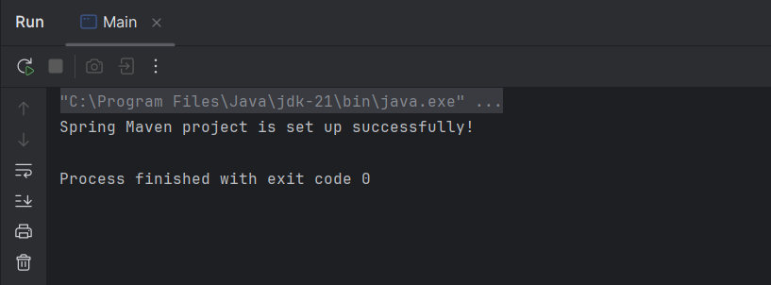

**Explanation:**

To verify that the **Maven project and Spring dependencies** were configured correctly, I created a simple bean and loaded it via Spring's ApplicationContext. The output confirms successful integration.